CSE520
Samuel Marrujo
Professor Yu
Lab 13
Draw a moving particle using GLSL for Android

In this lab, we are to create a square that moves across the screen, and use separate vertex/fragment shaders. I have completed the shader task, but the moving part was extremely difficult:
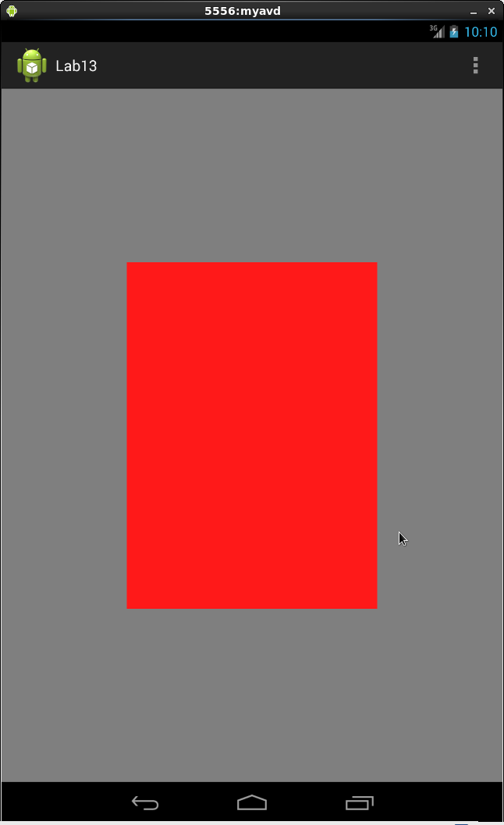
Code:

package opengl.lab13;

import java.nio.ByteBuffer;
import java.nio.ByteOrder;
import java.nio.FloatBuffer;

import java.io.IOException;
import java.io.InputStream;

import android.app.Activity;
import android.app.ActionBar;
import android.app.Fragment;
import android.content.Context;
import android.os.Bundle;
import android.view.LayoutInflater;
import android.view.Menu;
import android.view.MenuItem;
import android.view.View;
import android.view.ViewGroup;
import android.os.Build;

import android.util.Log;
import android.widget.EditText;

import android.opengl.GLES20;

public class Square {
// Source code of vertex shader

private static String LOG_APP_TAG = "tag";
private String vertexshaderCode = null;
private String fragmentshaderCode = null;

private int program;
private int vertexShader;
private int fragmentShader;
private FloatBuffer vertexBuffer;
private int vertexCount = 3;
private Context context;

// number of coordinates per vertex in this array
static final int COORDS_PER_VERTEX = 3;
static float squareCoords[] = { // in counterclockwise order:
-0.5f, 0.5f, 0.0f, // top left vertex
0.5f, 0.5f, 0.0f, // top right vertex
-0.5f, -0.5f, 0.0f, // bottom left

};
private float deltaT = 0.0f;
// Set color of displaying object
// with red, green, blue and alpha (opacity) values
float color[] = { 0.0f, 1.0f, 0.0f, 1.0f };

// Create a Triangle object
Square( Context context0 ){
// create empty OpenGL ES Program, load, attach, and link shaders
context = context0;
vertexshaderCode = getVertexShaderCode();
fragmentshaderCode = getFragmentShaderCode();
program = GLES20.glCreateProgram();
vertexShader = loadShader(GLES20.GL_VERTEX_SHADER, vertexshaderCode);
fragmentShader = loadShader(GLES20.GL_FRAGMENT_SHADER, fragmentshaderCode);
GLES20.glAttachShader ( program, vertexShader );// add the vertex shader to program
GLES20.glAttachShader(program, fragmentShader); // add the fragment shader to program
GLES20.glLinkProgram(program); // creates OpenGL ES program executables
GLES20.glUseProgram( program); // use shader program

// initialize vertex byte buffer for shape coordinates with parameters
// (number of coordinate values * 4 bytes per float)
// use the device hardware's native byte order
ByteBuffer bb = ByteBuffer.allocateDirect( squareCoords.length * 4);
bb.order(ByteOrder.nativeOrder());

// create a floating point buffer from the ByteBuffer
vertexBuffer = bb.asFloatBuffer();
// add the coordinates to the FloatBuffer
vertexBuffer.put(squareCoords);
// set the buffer to read the first coordinate
vertexBuffer.position(0);
} //Triangle Constructor

protected String getVertexShaderCode()
{
InputStream inputStream = null;
String str = null;
try {
inputStream = context.getResources().openRawResource(R.raw.vshader);
byte[] reader = new byte[inputStream.available()];;
while (inputStream.read(reader) != -1) {}
str = new String ( reader );
} catch(IOException e) {
Log.e(LOG_APP_TAG, e.getMessage());
}

return str;
}

protected String getFragmentShaderCode()
{
InputStream inputStream = null;
String str = null;
try {
inputStream = context.getResources().openRawResource(R.raw.fshader);
byte[] reader = new byte[inputStream.available()];;
while (inputStream.read(reader) != -1) {}
str = new String ( reader );
} catch(IOException e) {
Log.e(LOG_APP_TAG, e.getMessage());
}

return str;
}

public static int loadShader (int type, String shaderCode ) {

// create a vertex shader type (GLES20.GL_VERTEX_SHADER)
// or a fragment shader type (GLES20.GL_FRAGMENT_SHADER)
int shader = GLES20.glCreateShader(type);

// pass source code to the shader and compile it
GLES20.glShaderSource(shader, shaderCode);
GLES20.glCompileShader(shader);

return shader;
}
public void draw(float[] mvpMatrix) {
int mMVPMatrixHandle = GLES20.glGetUniformLocation(program, "uMVPMatrix");
GLES20.glUniformMatrix4fv(mMVPMatrixHandle, 1, false, mvpMatrix, 0);
GLES20.glDrawArrays(GLES20.GL_TRIANGLES, 0, vertexCount);
//draw();
}
public void draw() {
// Add program to OpenGL ES environment
GLES20.glUseProgram(program);

// get handle to vertex shader's attribute variable vPosition

int positionHandle = GLES20.glGetAttribLocation(program, "vPosition");
int deltaTHandle = GLES20.glGetUniformLocation(program, "deltaT");
// Enable a handle to the triangle vertices
GLES20.glEnableVertexAttribArray(positionHandle);

// Prepare the triangle coordinate data
GLES20.glVertexAttribPointer(positionHandle, COORDS_PER_VERTEX,
GLES20.GL_FLOAT, false, 0, vertexBuffer);

// get handle to fragment shader's uniform variable vColor
int colorHandle = GLES20.glGetUniformLocation(program, "vColor");

// Set color for drawing the triangle
GLES20.glUniform4fv(colorHandle, 1, color, 0);
GLES20.glUniform1f( deltaTHandle, deltaT);
deltaT += 0.2;
// Draw the triangle
GLES20.glDrawArrays(GLES20.GL_TRIANGLES, 0, vertexCount);
//GLES20.glVertexAttrib3f(positionHandle,10,10,0);
// Disable vertex array
GLES20.glDisableVertexAttribArray(positionHandle);
}
}

